Calculus 1 Lecture 2.4: Applications of the Derivative

Rates of change
Example:
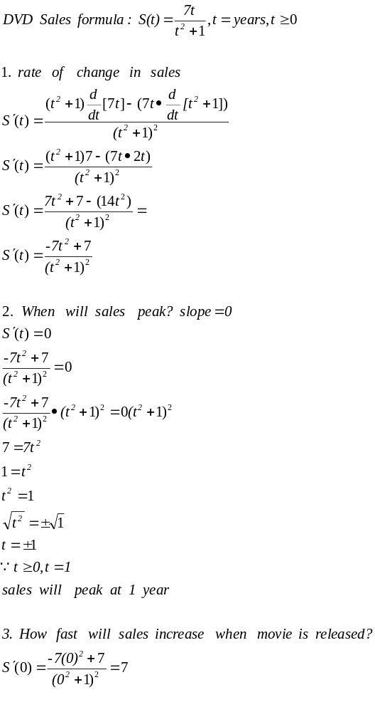

Instantaneous Velocity
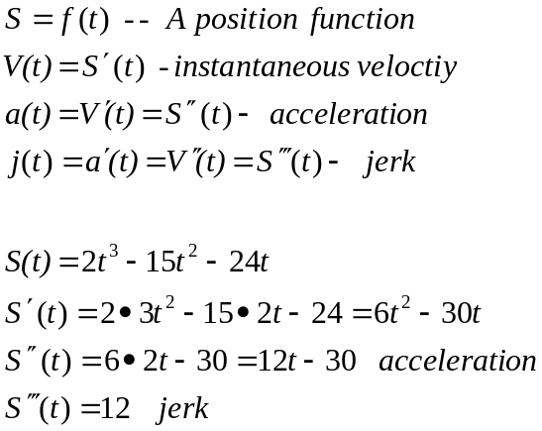

Heights of objects
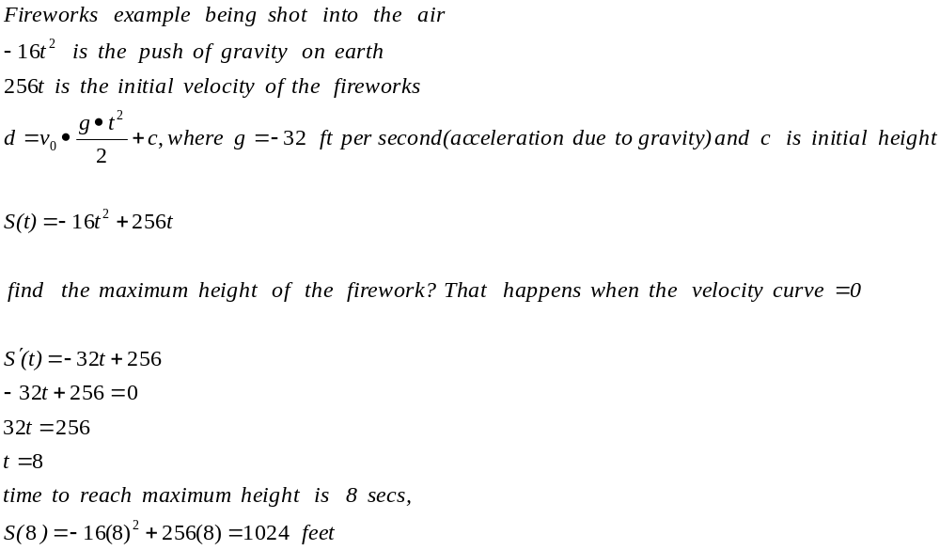

Marginal Costs
